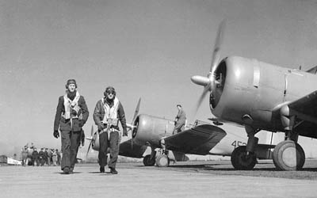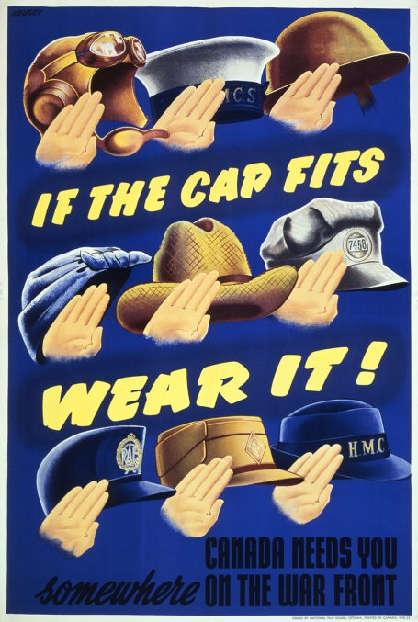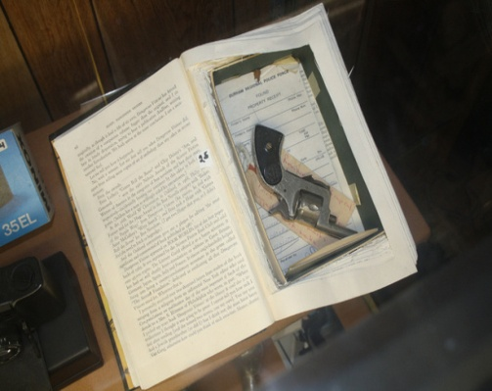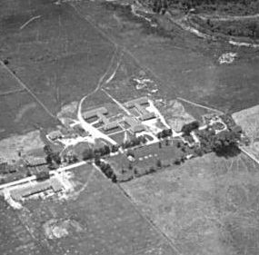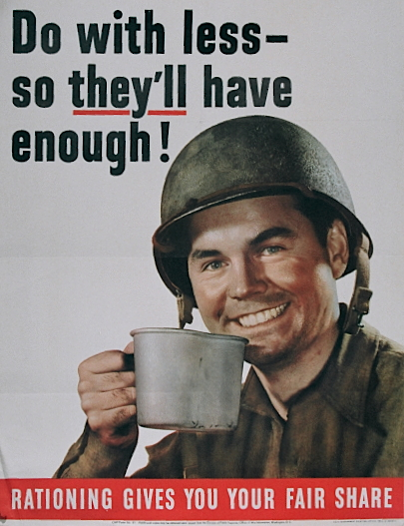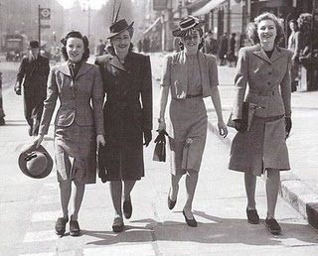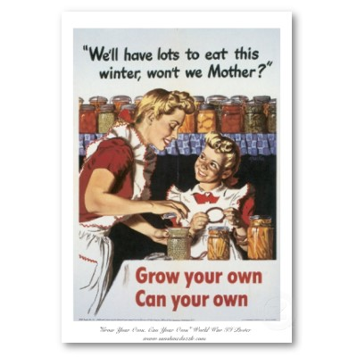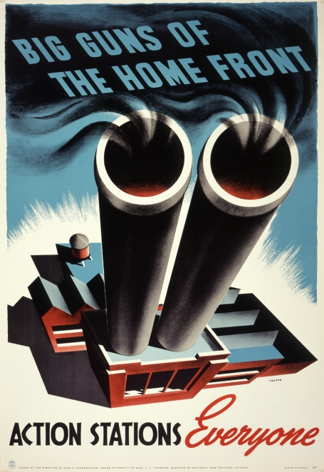

**2. Describe the British Commonwealth Air Training**

**Plan. Why should Canadians be proud of this project?**

**1. How did Canadians on the Home front contribute to the war effort?**

Read pp. 154-164 in your text and complete the following:

**Canadian Response on the Home Front**

The Toronto Sun, Thursday, May 20, 2010

**3. a) What was “Camp X”?**

**b) What do you think made Canada a good location for a training facility like**

**this?**

**c) Do you support Hodgson’s campaign to keep historical artifacts like those**

**from Camp X in Canada? Explain.**

**Carola Vyhnak**

Urban Affairs Reporter

A dagger lipstick, poison gas fountain pen and revolver in a hollowed-out book are among the “James Bond toys” included in a collection of wartime artifacts that a Durham Region historian is working furiously to save. The privately owned collection, which includes articles from the top-secret Camp X spy training school, is up for sale — asking price $1 million — and in danger of leaving Canada, says Lynn Philip Hodgson. “It is the only one of its kind in the world. There is nowhere else to see Camp X artifacts,” says Hodgson, who has spent half his life uncovering the spy school’s secrets. “If it leaves the country — it will go to the States because that’s where the money is — it’s gone for good,” he says, calling such a move disastrous for Canada’s heritage. Items from Camp X, near the Whitby-Oshawa border, where Allied agents trained during World War II, make up about 25 per cent of the Robert Stuart Aeronautical Collection of intelligence and military artifacts. Housed in an Ontario Regiment building at the south end of Oshawa Airport, the collection was amassed over 45 years by local resident and history buff Robert Stuart. He died seven years ago and now his daughter Deirdre Stuart is selling the entire lot “for personal reasons.” Since advertising it on an aviation website, [Barnstormers.com](http://www.barnstormers.com/cat.php?mode=search), two weeks ago, she’s heard from potential buyers in Canada and outside the country. “People are getting up in arms about it leaving the country, but we don’t know yet. We’re considering all our options,” she says. “People have to realize this is a private collection and we will do what we choose to do with it.” Passionate about history like her father, Stuart adds she and her mother Lois would like it to remain in Canada. Hodgson isn’t wasting any time, having set up a [Facebook](http://www.facebook.com/#!/pages/Save-The-Collection/10150094235220182?ref=search&sid=581780489.2412587987..1) page and mobilized a small army of experts, politicians and business professionals in a “Save the Collection” campaign to acquire it through fundraising and government grants, and find a permanent home in Durham. While there’s no denying the collection’s historical value, Hodgson scoffs at the $1 million price tag. “She’s dreaming in technicolour,” he says, suggesting a more realistic $250,000. Among Camp X’s trainees was James Bond creator Ian Fleming, who applied what he learned to his famous “007” character. In addition to gadgets for secret agents, the collection includes radios the school used to communicate with England during the war. “They’re in working order with the original tubes,” says Hodgson. “You can still pick up Morse code from ships in the St. Lawrence.” There’s also a one-shot pistol called the “Liberator,” made by General Motors during the war years, and a scale model of Camp X, adds Hodgson, who leads walking tours of the site, now open parkland on the shore of Lake Ontario. He’s already heard from high school students eager to help, many of whom know about Camp X from his [website](http://webhome.idirect.com/~lhodgson/canadaspymuseum.html) and have visited the 33-year-old museum by the busload. Some, from Port Perry, volunteered their time to set up displays when Robert Stuart moved it from a Quonset hut to its current, city-owned home at the Stevenson Rd. airport in 2002. “They’ve been heavily involved,” Hodgson says of the teens, noting it’s partly for their benefit that the collection should stay in Canada.

**Secret spy gadgets from Whitby's Camp X go up for sale**

**Historian fights to keep WW II spy-school collection in Canada**

**7. How did government advertising and programs encourage individual and community efforts supporting the war? Describe:**

**a) One Percent Scheme**

**b) Propaganda posters/ newspaper articles**

**c) “Loose Lips Sink Ships”**

**d) Victory Gardens**

**e) Rationing/ Ration Coupons**

**4. a) Describe the significant contribution that Canadian industries made in supplying war materials and supplies to Europe.**

**b) Write down three facts or pieces of evidence that show that Canada’s war production expanded significantly between 1939-1945.**

**5. How did Canadian women contribute to the war effort?**

**6. How did the radio and media industry change how Canadians**

**experienced this war as compared with WWI?**